**Excel Project**

Case Study

AstroSage Analysis

**Project by:**

**Hashim Rafiq Khan**

**Newton Batch: April 2025**

**Date: 18- April-2025**

# **AstroSage Dataset**

The AstroSage Dataset consists of these columns:

* **_id:** Unique identifier for each record.
* **user:** User ID associated with the record.
* **chatStatus:** Status of the chat (ex. Completed, incomplete, failed, pending, started)
* **guru:** Profile ID of guru
* **guruName:** Name of the guru.
* **gid:** Unique guru ID.
* **uid:** Unique user ID.
* **consultation Type:** Type of consultation (ex. Call, Chat, Live Public calls, Complimentary).
* **website:** Source of the contact or consultation (ex. App, gurucool website).
* **Refund Status:** Indicates if the session is refundable or not (ex. Refunded, no-refund, Processing).
* **is WhiteList User:** Boolean indication of the user is whitelisted.
* **chat Seconds:** Duration of the chat in seconds.
* **queue:** Boolean indication if the session was queued.
* **FreeCall:** Indicating that whether the call service was free or paid.
* **Free Chat:** Indicating that whether the chat service was free or paid.
* **CreatedAT:** Status of creation date and time.
* **updatedAt:** Status of update date and time.
* **v:** Review Version key.
* **statementEntryId:** Identifier for the statement entry.
* **chatStartTime:** Start time of the chat.
* **chatEndTime:** End time of the chat.
* **timeDuration:** Duration of the chat session.
* **callChannel:** Channel used for the call.
* **callIvrType:** VR type used for the call.
* **callStatus:** Status of the call.
* **CallSid:** Unique identifier for the call session.
* **amount:** Amount charged for the session.
* **astrologerCallStatus:** Status of the astrologer for the call.
* **astrologerOnCallDuration:** Call duration of the astrologer.
* **astrologersEarnings:** Earnings of the astrologer from the session.
* **netAmount:** Net amount after deductions.
* **region:** Region of the user.
* **userCallStatus:** Status of the user's call.
* **userOnCallDuration:** Duration of the user's call.
* **rating:** Rating based on the session from the User

# **Tasks**

**Objective Questions**:

1. What is the total no. of tables present in the data?

Ans. Total no of predefined tables present in the dataset: 1

1. What is the total no. of attributes present in the data?

Ans. Predefined Attributes present in the dataset: 37

1. The data consists of some inconsistent and missing values so ensure that the data used for further analysis is cleaned.

Ans. Data Cleaning Process:

* Hid a few irrelevant columns: - time-duration (some irrelevant data as per the description provided in the presentation), isWhiteListUser and queue columns are ir-relevant (they have single values)
* Did some cleaning and extraction over the following columns.

**createdAT, updatedAt, chatStartTime and chatEndTime**

* chatStartTime and chatEndTime column name have been interchanged to get an accurate time period and maintain consistency.
* Derived a new Column from createdAT named as Month to categorise the timeframe

1. What is the change in daily call volume day by day and also find the average daily call volume.

Ans.

The Average number of calls is calculated by the aggregate Function AVERAGE() from the pivot table having rows = date and values = count of Callsid. Taking the Average of ‘Count of Callsid’ we would get a single day average of calls.

=AVERAGE(B4:B37) is used to calculate the average number of calls in the day by day pivot table.

To check the day by day change in percentage we could use basic calculation by dividing the current element with the previous element and using a conditional formatting for a clear descriptive value.

On 03/01/2024 the call volume dropped drastically with a rate of -167% which is the highest drop in the months of December and January.

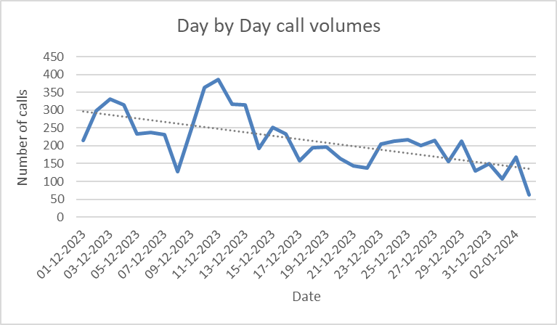

In the above graph we can determine the daily call volumes and with time the average call volumes are decreasing.

1. Which months experienced the highest and lowest call volumes?

Ans.

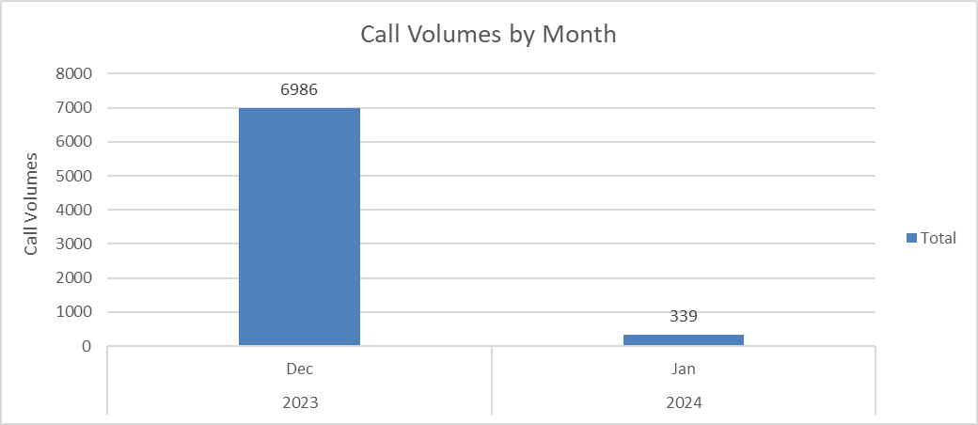  
Since the current dataset possesses the data for the month of Dec 23 and starting week of Jan 2024, so aggregating all the calls value using a pivot table and with the data we could identify that Dec 23 has the highest call volume with 6986 calls.

*The above-mentioned calls have been filtered and ‘Failed’ call status data have not been considered for analysis.

**6**. What is the total operational cost for that month?

Ans.

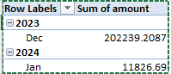

Total operational cost for the month of Dec 2023: **202239.20**

Total operational cost for the month of Jan 2024: **11826.69**

1. What is the average number of calls handled per agent per day?

Ans. The average no of calls handled by per agent per day is: **1.92**  
This is being calculated by aggregating the sum of all calls divided by the count of all gurus and further divided by the number of unique days.

**Total Calls received** = 8508 including failed

**Total Astro Guru’s** = 131 (Count of guru_unique_id)

**Total no. of days** = 34

**Average no. of calls handled by each guru** = **Total Calls received / Total Astro Guru’s**

=8508/131 = 64.95

Total no. of Call handled by Guru per day = Average no. of calls handled by each guru / Total no. of days = 64.95/34 = 1.92

Round of 1.92 is 2.

Therefore, on an average the calls handled by Guru per day is 2 approx.

1. How many repeat callers are there, and what percentage of total calls do they represent?

Ans. For Total Repeat callers, selected the dataset and derived a pivot table with user_id as Rows and Callsid as values.

Total unique callers is being calculated from the pivot table using =COUNTIF(O5:O3428,"=1")

Total callers is the count of Row Labels column of the pivot table which comes out as 3424

Repeat callers is the difference between Total callers & Total Unique Callers which is 1234

Total number of calls = 8315

Calls done by repeat callers = 5977

Total First calls of repeat callers (To be excluded from call percentage calculation) = 1208

**Percentage of total calls done by repeat callers = 57 %**

1. What is the total sales generated by the call centre for each product category?

Ans.

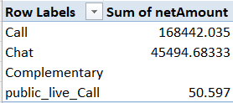

The comprehensive sales revenue generated by different product categories is mentioned in the pivot table.

1. How many calls were made for each user ID and guru ID?

Ans.

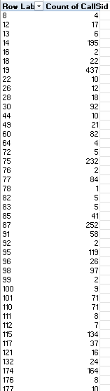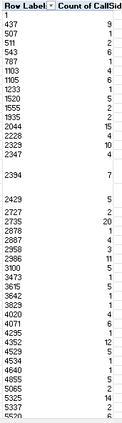

The mentioned pivot tables identify the number of calls done by each user and each guru respectively.

1. What is the correlation between call duration and customer satisfaction?

Ans.

The correlation between call duration and customer satisfaction is derived by the correlation function: **=CORREL(FILTER(data!AN2:AN28028, data!AL2:AL28028="Completed"), FILTER(data!AM2:AM28028, data!AL2:AL28028="Completed")))**

The correlation value after calculation is: **-0.001406661**

This represents there is an extremely small inverse correlation between the two attributes which can be neglected a can determine there is no relation between the two attributes.

1. Which guru has the highest and lowest customer satisfaction scores?

Ans.

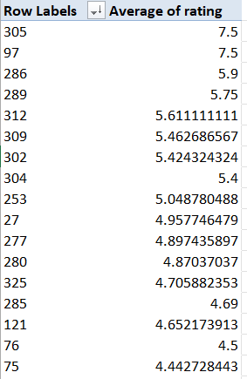



The highest and lowest satisfaction rating of guru is calculated by deriving a pivot table and selecting g_id in rows and Average of rating in values section.

Then sorting the pivot table in descending on the average of the rating column.

Then Xlookup is used to get the name of the guru from the data table using the g_id obtained from Pivot table as lookup value.

**Tarot Mystical** scored the **highest overall rating** while **Tarot Rittika** scored the **lowest overall rating.**

1. What is the average customer satisfaction score by month?

Ans.

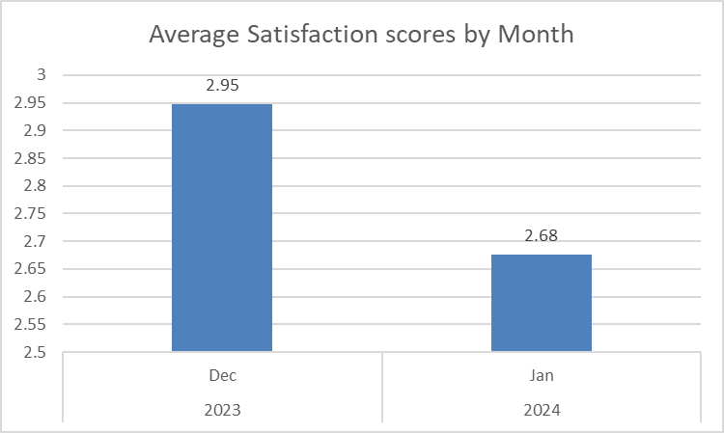

The average satisfaction score by month is derived by taking a pivot table, taking the month attribute as rows and Average of rating attribute in the values tab. Inserting a column chart clearly depicts the average monthly ratings.

1. How many categorical columns are there in the data?

Ans. There are 15 categorical columns in the dataset which are mentioned below:

chatStatus, consultationType, website, refundStatus, isWhiteListUser, queue, freeCall, freeChat, callChannel, callIvrType, callStatus, astrologerCallStatus, region, userCallStatus, rating

**Subjective Question:**

1. Should the investment be used to hire more agents, improve training programs, or upgrade call center technology?

Ans: After analysing the dataset, the following findings have been observed:

1. The number of calls received by the call centre is decreasing at an exponential rate indicating low customer retention.

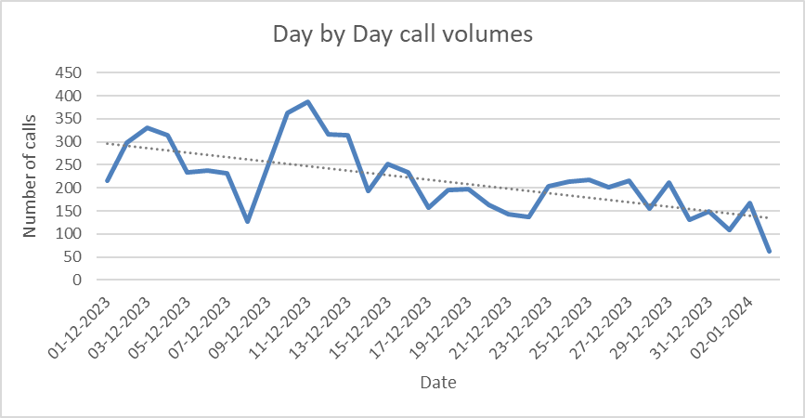

1. The call centre agent distribution is quite ineffective as some of the agents are getting high volume of chat or call requests and some of them are having minimal call/chat requests. This is being analysed by grouping the calls as per the Guru id and count of calls attended in a pivot table and sorting it to get the distribution.

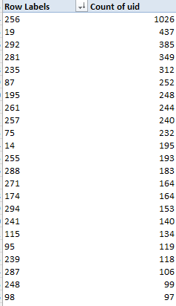

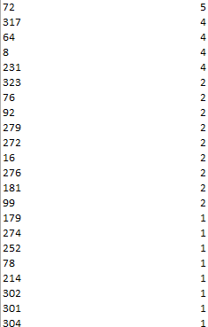

Here we can analyse that some gurus have high traffic while some are having less volume of calls.

1. The quality of the consultations of customers is not satisfactory as in both the calls & chat category only about 32 % of total consultation is completed and the rest are either incomplete/ busy/ no answer.

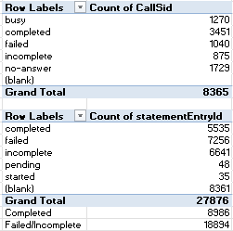

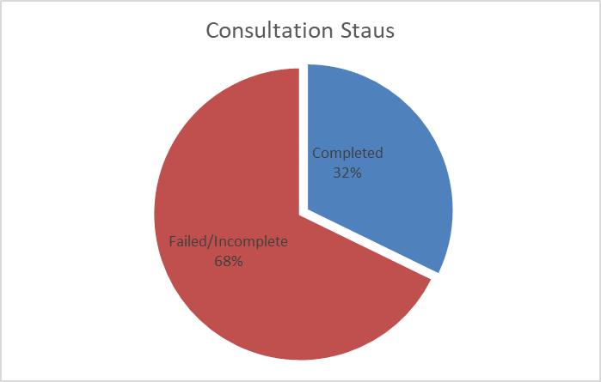

We can identify from the pivot table the number of consultations being completed.

Recommendations:

Some portions of the investment should be done on the following aspects:

**Technology Upgradation**: - Technology of the application and gurukul platform should be enhanced to have a definite distribution of calls/chats among all the gurus seamlessly without dropping the calls. An enhanced call managing infrastructure should be developed.

**Training Agents**: - Proper structured training sessions should be given to specific agents to improve their customer satisfaction ratings. Training should be done by expert individuals for better quality of gurus enhancing the revenue and number of consultations.

1. What are the potential risks of each investment option (hiring, training, technology upgrades), and how can they be mitigated?

Name the chart/spreadsheet function you will use for solving the problem?

Ans: Potential risks for Hiring:

* **High Initial Costs**: Hiring new agents with broader expertise in Astrology could lead to incur initial heavy expenses.

*Mitigation strategy-* The hiring should consist of people of mid-range expectations but with higher passion. New talent to be chosen who have higher adaptability and learnability.

* **Adaptability:** New talents would require specific time to adapt to the fast-paced growth aspirations leading to a delay in return on investment.

*Mitigation strategy-* To make a perfect alignment of organisational and employee goals, a proper training program to be scheduled to enhance the motivation and the adaptation of the new technology

Potential risks for Training:

* **High Costs:** An expert training to the employees could put some heavy costs on the company both in short- and long-term productivity.

*Mitigation strategy-* Training effectiveness to be measured throughout the process and valuable feedback to be considered to enhance the quality of training in future days.

* **Employee Retention:** After expertise training employees would prefer to enhance their pay scale searching for different opportunities in the market.

*Mitigation strategy*- Imply recognition strategies and retention bonuses to retain the trained individuals for a longer period.

Potential risks for technology upgradations:

* **Deploying challenges**: While technology updates could create a positive impact on the growth of the organisation. However, implementing technology updates could result in various technical issues at the beginning.

*Mitigation strategy-* Implementing the new technology in a phase wise manner would create sustainable outcomes while resolving bugs at every stage.

* **High Cost:** New Technologies come at a higher price and have a higher running cost and thus would impact the overall budget of the organisation in the long term.

*Mitigation strategy-* Defining a Return on Investment analysis would result in the budget allocation and planning for the necessary changes.

Excel provides a various number of tools we can use for the risk analysis:

* **WHAT IF Analysis:** Goal seek and Scenario Manager could be helpful in determining the risk factors in the upcoming investment plans.
* **Forecasting:** Forecasting gives us an approximate value in the future for ROI and provides us with the data for the near future

1. How does AstroSage call center performance compare to that of AstroGuru in terms of average call volume, customer satisfaction, and agent performance?

Will you use any aggregation function or a visualization here to solve the problem?

Ans. The current dataset is not sufficient to compare with another organisation.

[AstroGuru Data have not been provided]

1. How can the call center improve its handling of peak call periods to ensure high customer satisfaction?

Mention the functionality which you will use for giving the suggestions, will it be any aggregated function or a visualization?

Ans.

Analysing the dataset, we could observe that most of the calls are being placed in the time period of 5 AM to 5 PM (5854 calls) which is aggregated to 79.9 % of the total calls.

We used a pivot table to group the calls data by the hourly basis and derived a column chart to analyse the distribution of the calls.

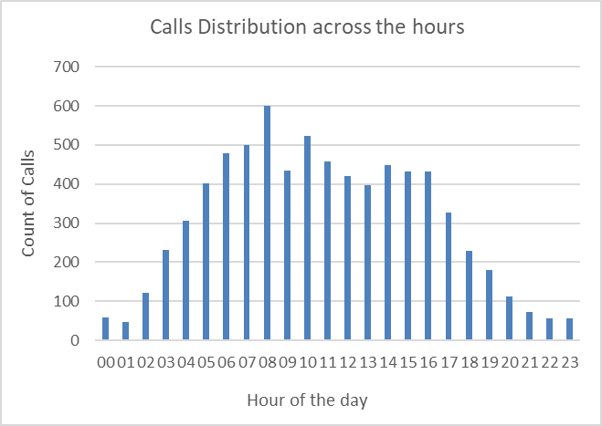

From the analysis, it is clear that the peak call periods range from 5 AM till 5PM.

Recommendations*:* The Agent’s shift distribution should be managed to handle calls at the peak time period by assigning 80% of agents into the derived time span. And for the time period other than the peak call hours, the rest 20% of agents were able to handle seamlessly. This would prevent burnouts and stress among the agents and maximum calls could be completed positively impacting the customer satisfaction.

1. Based on historical data, what strategic initiatives should be prioritized to improve overall efficiency and customer satisfaction?

Ans.

Based on the historical data analysis, it has been identified that certain agents exhibit high failure rates in customer interactions, coupled with low customer satisfaction ratings. These agents represent an opportunity for targeted intervention, where focused training can lead to significant improvements in both their performance and overall customer experience.

#### **Identified Issues:**

1. **High Failure Rates**: Specific agents have been flagged for consistently high call or interaction failure rates. These failures may be due to a range of issues, including ineffective communication, inadequate problem-solving abilities, or technical knowledge gaps.
2. **Low Customer Ratings**: All the agents spread across the rating range of 0 -10 where majority of the ratings are below 4 due to lack of customer satisfaction as the agents were not successful in solving customers’ queries

52.88 % of Gurus received ratings below 4 which constitutes to the lower customer satisfaction values.

#### **Recommended Actions:**

To address these issues, it is recommended to implement **targeted training programs** focused on improving the following key areas:

* **Communication Skills**: Training should emphasise improving how agents communicate with customers, ensuring they can clearly explain solutions and maintain professionalism during challenging conversations.
* **Problem-Solving Abilities**: Agents should be equipped with strategies to handle complex customer queries more efficiently, reducing frustration and interaction time.
* **Technical Knowledge**: For agents struggling with system operations or product-related issues, additional training in technical aspects will help improve their competency and confidence in handling customer interactions.

#### **Post-Training Assessment:**

After the targeted training sessions, it will be crucial to evaluate the effectiveness of these programs by tracking key performance indicators (KPIs) such as:

* **Change in Failure Rates**: Monitoring whether there is a reduction in the agents' failure rates post-training will help assess the impact on performance.
* **Customer Satisfaction Improvement**: By analysing post-training customer satisfaction ratings, it can be determined if there is a noticeable increase in positive feedback following the intervention.

1. What can be the key factors contributing to high customer satisfaction scores, and how can these be leveraged to improve overall performance?

What is the basis for the suggestions? And mention how did you decide if the satisfaction score affect the ratings?

Ans.

Note: The Satisfaction scores taken into account is the average of rating provided by the customers.

The Key Factors contributing to the high customer satisfaction scores are:

**Interaction with expert agents:**

**Approach:** Agents having high demand and higher expertise contribute to the high customer satisfaction.

Low call volumes: Agents attending less customers enhances the experience of customers gradually providing a better consultation and overall rating. Overburdened agents could provide less efficiency to the customers and their rating drops.

**Performance Improvement strategies:**

To improve the overall performance well trained agents with effectively lower call volumes would provide a better output for the customers.

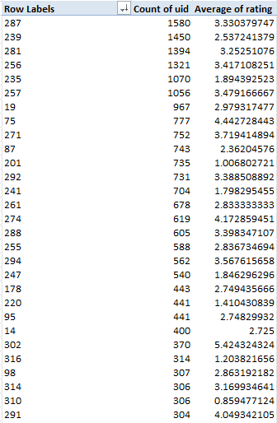

This pivot table shows the performance of the agents and their efficiency in handling the customers. The top agents who handle the most volume of calls is being shown in this part of the table.

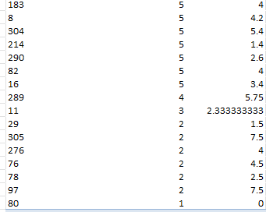The bottom part of the table shows agents showing poor performance with respect to having the number of calls and therefore handling efficiency decreases.

The distribution of interactions to be balanced using prioritising customer requirements to specific agents.

1. How should the call center balance the workload among agents to ensure optimal performance and avoid burnout?

Mention your approach and spreadsheet function for the answer?

Ans.

**1. Prediction of Peak Periods and Scheduling Adjustments**

* **Approach**: Analysing historical call data to predict peak periods and scheduling employees accordingly.  
  **Recommendations**: While predicting peak periods using historical data is important, enhancing this method with **real-time predictive analytics** can further optimise workforce allocation. Utilising AI-driven software for demand forecasting allows the system to dynamically adjust schedules as new patterns emerge, such as during holidays, promotional campaigns, or unexpected events. This ensures a more agile response to changes in call volume.

#### **2. Introducing Shift Work for Stress Management**

* **Approach**: Implementing shift work to ensure that agents do not consistently work during high-stress periods, thus sharing the workload across the team.  
  **Recommendations**: Instead of traditional shift rotations, consider a **flexible work-hour model** that adjusts shifts based on the preferences and energy levels of individual agents. By adopting **employee-centric scheduling**, where agents are involved in choosing their work hours within a defined framework, management can increase employee satisfaction and reduce burnout. In conjunction with regular team debriefs and stress relief breaks, this approach fosters better long-term productivity and mental well-being.

#### **3. Skill-Based Routing for Efficient Call Handling**

* **Approach**: Implementing skill-based routing to ensure complex or high-priority calls are handled by experienced agents, while simpler queries go to less experienced agents.  
  **Recommendations**: While skill-based routing is a sound approach, a more sophisticated version would be **AI-powered dynamic skill routing**. This system not only assigns calls based on predefined skills but also uses machine learning to continuously assess and update agent skills. It can identify patterns, track performance metrics in real-time, and route calls more efficiently by taking into account past performance on similar issues, reducing resolution time and enhancing customer satisfaction.

Some of the agents are facing huge volume of calls as shown in this pivot table.

While some of the agents only handle a few calls showing the deviation in call connection efficiency.

#### **4. Mental Health Support and Stress Reduction Initiatives**

* **Approach**: Making mental health services and support tools available to help agents manage stress and avoid burnout.  
  **Recommendations**: Beyond providing traditional mental health support, integrating **wellness programs** directly into the workplace culture can provide ongoing mental and emotional support. This includes offering access to **stress-relieving activities** like mindfulness exercises, flexible time-off policies, and wellness apps, as well as hosting **mental health workshops** led by experts. Encouraging open communication about mental health and providing continuous training on emotional intelligence will help agents cope with daily stress more effectively.

#### **5. Real-Time Performance Monitoring and Workload Balancing**

* **Approach**: Utilising tools to monitor real-time metrics such as call handling time, queue lengths, and agent workload. Management can intervene when one agent is receiving too many calls.  
  **Recommendations**: Implementing an **automated workload distribution system** that uses real-time data to dynamically adjust call assignments can prevent uneven workloads without constant managerial intervention. This system could redistribute tasks more fairly and ensure that no agent is overwhelmed. Additionally, coupling these tools with **agent performance dashboards** can empower agents to self-monitor their workloads and request assistance when needed, fostering autonomy and efficiency.

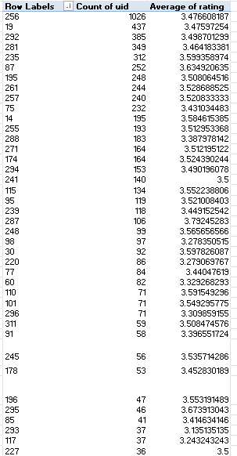

In this pivot table we could identify & monitor the efficiency of the agents who handled a large volume of calls along with the respective average rating they received.

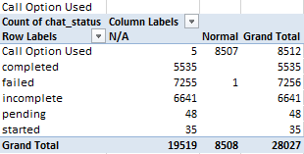**Insights:**

Total Calls received = 8508 including failed

Total Astro Guru’s = 131 (Count of guru_unique_id)

Total no. of days = 34

Average no. of calls handled by each guru = Total Calls received / Total Astro Guru’s

=8508/131 = 64.95

Total no. of Call handled by Guru per day = Average no. of calls handled by each guru / Total no. of days = 64.95/34 = 1.92

Round of 1.92 is 2.

Therefore, on an average the calls handled by Guru per day is 2 approx.

To ensure optimal performance and avoid burnout:

* More agents can be asked to be available during the peak hours by assigning them to shifts to give the sessions accordingly to the users to avoid the incomplete status of the calls or chats.
* Technology can be upgraded by having AI chatbots by providing the services based in the users reply and traffic tools can be used to monitor by assisting the users to schedule the sessions accordingly based on the sessions already booked by the users.
* As we have seen some good ratings provided for the chat sessions company can utilize the services like chatbot which can autoreply or schedule the session based on the slot availability.

1. What new technologies or tools could be implemented to enhance call center operations and customer service?

Ans.

To enhance call centre management and customer relations, the implementation of advanced technologies is essential. Specifically, the integration of **AI-powered tools** can drive significant improvements in both operational efficiency and customer satisfaction. Below is a detailed recommendation on how Artificial Intelligence (AI) and Machine Learning (ML) technologies can be leveraged to achieve these goals.

**1. AI and Machine Learning**

AI and machine learning technologies offer transformative potential for call centres by automating routine tasks and optimising resource allocation. Through the use of AI-driven tools, the workload on human agents can be reduced, allowing them to focus on more complex inquiries and improving the overall quality of customer interactions.

**2. AI-Powered Chatbots**

One of the most effective applications of AI in a call centre is the use of **AI-powered chatbots**. These chatbots, powered by natural language processing (NLP) and machine learning, are capable of handling simple customer inquiries autonomously. By managing routine interactions, chatbots reduce the volume of calls routed to human agents, thereby lowering call traffic and improving agent productivity.

NLP-based chatbots are designed to mimic human conversations, providing customers with responses that feel personalised and contextually appropriate. These chatbots can solve most basic customer service problems without human intervention, freeing up agents to handle more complex tasks, which ultimately leads to increased operational efficiency and faster response times for customers.

**3. Recommended Tools**

To implement AI-powered chatbots, the following tools are widely recognized for their efficacy and ease of integration into call centre operations:

* **IBM Watson**: A robust AI platform that enables the creation of intelligent chatbots capable of managing a wide range of customer queries.
* **Google Dialog Flow**: A flexible and scalable NLP-based chatbot solution that can be customised to meet specific business needs, offering smooth customer interactions.
* **Zendesk Answer Bot**: A customer support-focused tool that automates responses to frequently asked questions, reducing the workload on agents and improving response times.

1. What metrics should be included in the final dashboard to provide a comprehensive view of call center performance and guide investment decisions?

Ans.

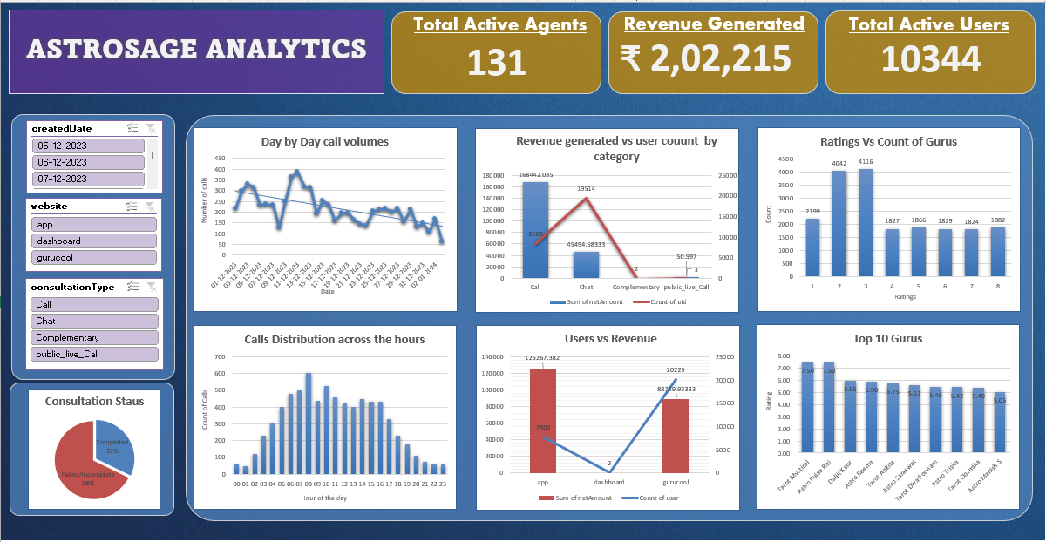

Metrics that can be included in the final dashboard to optimize the business and identify any underlying issues can be:

Filters:

1. Consultation Type Filter
2. Platform Filter (website or app)
3. Month Filter

Metrics on which these filters act upon are:

* Total Revenue Generated: This shows the total revenue of the business from all of its activities. This can be filtered out to gauge the income from different consultation types (call, chat or both) as well as from different platforms(app, website or both). It is an important metric to gauge the overall performance.
* Total active gurus/agents: Another important metric that measures the workforce available to serve the customers. This can also be filtered through the provided filter options.
* Total Active Users: This visualizes the daily activity of users on different platforms (app, gurucool,etc.). It can be an important metric to measure the number of users coming to the business daily. It can give an overview of the performance of business and any changes occurring.
* Daily activity on Astrosage: This chart visualizes the trend of overall daily activity on the Platform(all) and can be filtered via the available filters to view the specifics of the business.
* Users v/s Revenue: It gives an overview of the total users and the revenue generated by different consultation types (e.g. Call, chat, etc). It can be used to analyse the income from activity of users of different consultation preferences and the revenue/income generated from them.
* Platform Activity Overview: This gives the percentage distribution of the activity on various consultation preferences (chat, call,etc.). It gives an overview of the type of consultation preferred by the users.
* Call Volumes across hours: This is a very important metric that shows the peak call hours to determine which time period maximum calls were being done. This metric shows a distribution of call volumes in the whole span of 24 hrs.
* Consultation Status: This metric provides an accumulated status of consultations which are completed and compares it with the failed statuses.
* Rating vs Count of gurus: This metric visualises the ratings and the distribution of number of gurus as per the rating.
* Top 10 Gurus: This metric enhances our views on the Top 10 Gurus in the selected criteria.

1. How would you allocate a 1 crore rupee investment to optimize operational efficiency, enhance customer satisfaction, and boost profitability, and what analysis-based recommendations would you offer to support this?

[you have to give bullet pointers in order to answer this question]

Ans.

The budget of 1 Crore could be allocated / distributed for the recommended strategies as per the following:

* **Technology Upgradation*:*** Technology Infrastructure upgradation requires huge amounts to be invested upon for smooth operational convenience. Cloud Data centres would help to manage customer data efficiently. CRM tools would be used by employees for a better customer service approach and better overview of customers to the agents. More specialisations and developments in the application would attract more customers to the application.

Overall expenditure for the Technology could be roughly **40 Lakh Rs**.

* **Training & Development:** Training and development of the existing Agents would create a positive impact on the Customers as more customers would have a higher satisfaction score due to the expert consultation. Training of agents along with retention bonuses for the agents would cost the organisation around **30 Lakh Rs.**
* **Implementing New Technologies:**Implementing new AI chatbot and Machine Learning features in the application and Dashboard would resolve the agent’s burnout and the free consultation would be done by AI Chatbot relieving the overburdened agents and saving resources.

Implementation of AI would cost the organisation around **20 Lakh Rs.** for the subscriptions and commercial licences.

* **Marketing & Advertisements:**The organisation should spend an amount of **10 Lakh Rs.** from the budget to improve brand value against its competitors by channelling various marketing campaigns and indulging people to use their platform for better astrology recommendations. Valuable feedback to be taken from customers in the form of surveys and continuously improving the strategies for better outreach.